
School: ............................................................................................................. Campus: ....................................................... Academic Year: ...................... Subject Name: ........................................................... Subject Code: ..........................
Semester: ............... Program: ........................................ Branch: ......................... Specialization: .......................... Date: .....................................
(Learning by Doing and Discovery)
* Coding Phase: Pseudo Code / Flow Chart / Algorithm
Deploying The First Smart Contract in Solidity on Remix IDE:

- Code Compilation
  - Remix compiles the Solidity code into bytecode and ABI without manual setup — confirming that the contract syntax is correct and the compiler version matches.
  - Any syntax error or mismatch in compiler version stops deployment.
- Deployment Connection
  - MetaMask acts as the bridge between Remix and the Ethereum network (testnet or mainnet).
  - When you deploy, MetaMask pops up a transaction confirmation — showing:
    - Deployer’s wallet address
    - Gas fee estimation
    - Network name
  - This is the moment you realize that smart contracts are deployed through a blockchain transaction, not just “uploaded.”
- Transaction Processing
  - The transaction hash can be tracked on a block explorer (Etherscan/Sepolia Explorer).
  - After confirmation, the smart contract gets a permanent address on the blockchain.
  - Gas fee is deducted from your MetaMask account, proving deployment costs real value (even on testnet, gas fees are simulated).
- Interacting with the Contract
  - Once deployed, Remix automatically generates a UI for calling contract functions.
  - Function calls again trigger MetaMask confirmations (for state-changing functions).
  - You can verify data changes or emitted events directly in Remix.

Coding Phase: Pseudo Code / Flow Chart / Algorithm
Procedure for Writing Your First Solidity Contract (Using Remix) :

Step 1: Open Remix IDE
- Visit https://remix.ethereum.org
Step 2: Create a New File
- In the left sidebar, click on File Explorer → click the "contracts" folder.
- Click on the "+" icon to create a new file.
Step 3: Write the Smart Contract Code

pragma solidity ^0.8.0;
contract SimpleStorage{
uint public storedData;
constructor(uint data){
storedData = data;
}
function set(uint x)public {
storedData = x;
}
function get() public view returns (uint) {
return storedData;
}
}
Step 4: Compile the Contract
Step 5: Deploy the Contract
- Go to the Deploy & Run Transactions tab (icon: Ethereum with a play button).
- Environment: Select Injected Injected Provider MetaMask
- In the constructor input, add your message like "SimpleStorage"
- Click Deploy
Step 6: Interact with the Contract
After deployment:
- Under “Deployed Contracts
Use the buttons:
- getMessage(): reads the current message
- setMessage("New Message") → updates the message
- message() → public getter to see current message

* Softwares used
- Remix IDE
- MetaMask Wallet

- Testing Phase: Compilation of Code (error detection)
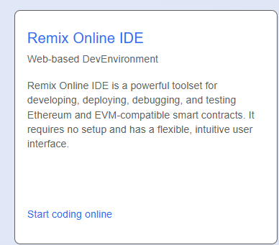
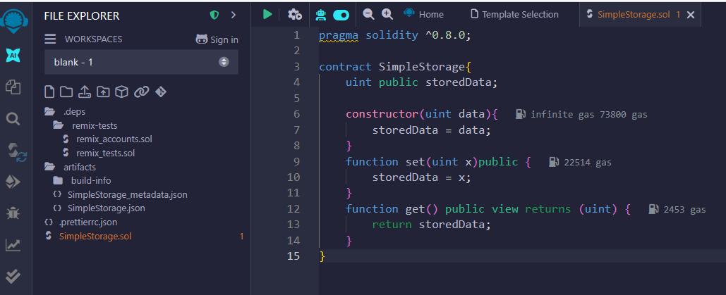

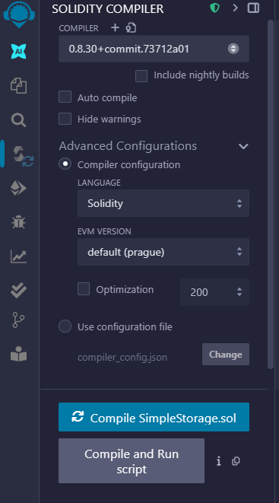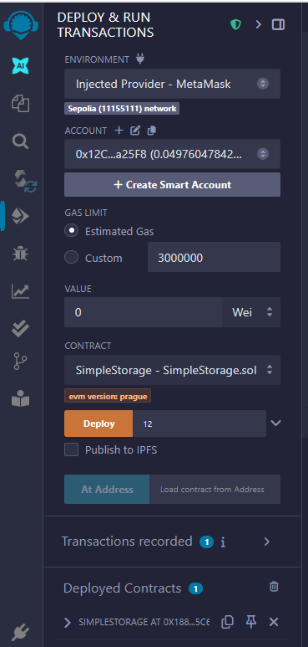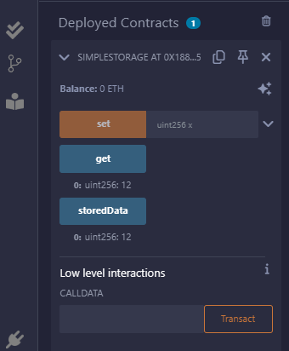

- Implementation Phase: Final Output (no error)

Implementation Phase: Final Output (no error)

- Implementation Phase: Final Output (no error)
Applied and Action Learning

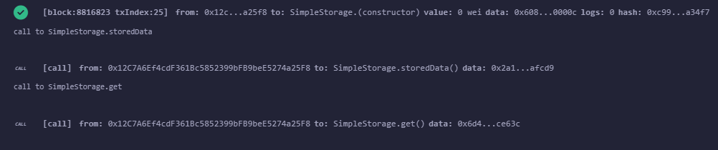

* Observations
- The contract is immutable once deployed — mistakes in logic require redeployment.
- Gas usage depends on the complexity of the constructor and storage operations.
- Even “simple” contracts create a permanent blockchain record and consume gas.
- MetaMask is not just a wallet, but also a transaction signer and broadcaster

ASSESMENT

Rubrics
Concept | 10
Planning and Execution/  Practical Simulation/ Programming | 10
Result and Interpretation | 10
Record of Applied and Action Learning | 10
Viva | 10
Total | 50


Signature of the Student:
Signature of the Faculty:

